# JS Applications Retake Exam – Sole Mates

You are assigned to implement a **Web application** (SPA) using JavaScript. The application should dynamically display content, based on user interaction and support user-profiles and CRUD operations, using a REST service.

## Overview

**Implement** a front-end app (**SPA**) for creating and managing **shoes**. The application allows visitors to browse through the shoes catalog. Users may **register** with an **email** and **password** which allows them to **create** their own shoe card. Item authors can also **edit** or **delete** their own publications at any time.

## Technical Details

You are provided with the following resources:

* **Project scaffold**: A **package.json** file, containing a list of common dependencies. You may change the included libraries to your preference. The sections **devDependencies** and **scripts** of the file are used by the automated testing suite, altering them may result in incorrect test operation.

To **initialize** the project, execute the command npm install via the command-line terminal.

* **HTML** **and CSS files**: All views (pages) of the application, including **sample** user-generated **content**, are included in the file **index.html**, which links to CSS and other static files. **Each view is in a separate section** of the file, which can be identified by a **unique class name or id** attribute. Your application may use any preferred method (such as a **templating library** or manual visibility settings) to display only the selected view and to **navigate** between views upon user interaction.
* **Local** **REST service**: A special server, which contains **sample data** and supports **user registration** and **CRUD operations** via REST requests is included with the project. Each section of this document (where applicable) includes details about the necessary **REST endpoints**, to which **requests** must be sent, and the **shape** of the expected **request body**.

For **more information** on how to use the included server, see **Appendix A: Using the Local REST Service** at the end of this document.

* **Automated tests**: A complete test suite is included, which can be used to test the correctness of your solution. **Your work will be assessed, based on these tests.**

For **more information** on how to run the tests, see **Appendix B: Running the Test Suite** at the end of this document.

**Do not use CDN** for loading the dependencies because it can **affect the tests in a negative** **way**!

**Note:** When creating HTML Elements and displaying them on the page, **adhere as close as possible to the provided HTML** samples. Changing the structure of the document may **prevent the tests** from running correctly, which will **adversely affect your assessment grade**. You may **add attributes** (such as **class** and **dataset**) to any HTML Element, as well as **change "href"** attributes on links and add/change the **method** and **action** attributes of HTML Forms, to facilitate the correct operation of a routing library or another method of abstraction. You may also add hidden elements to help you implement certain parts of the application requirements.

## Application Requirements

### Navigation Bar (5 pts)

Implement a **NavBar** for the app: navigation links should correctly change the current screen (view).

Navigation links should correctly change the current page (view). All users can see the site **logo** that should be a link to the **Home** page, **Seach** whichshould link to the **Search** page as well as the **Dashboard** whichshould link to the **Dashboard** page. **Guests** (un-authenticated visitors) can see the links to the **Login** and **Register** pages. The logged-in user navbar should contain the links to the **Add Pair** page and a link for the **Logout** action.

**User** navigation example:



**Guest** navigation example:



### Home page (10 pts)

Implement a static **Home page** for the app using the structure for it from the given resources. Картина, която съдържа текст

Описанието е генерирано автоматично

### Login User (5 pts)

The **included REST service** comes with the following **premade** user accounts, which you may use for development:

{ "email": "peter@abv.bg", "password": "123456" }

{ "email": "john@abv.bg", "password": "123456" }

The **Login** page contains a form for existing user authentication. By providing an **email and password** the app should login a user in the system if there are no empty fields.

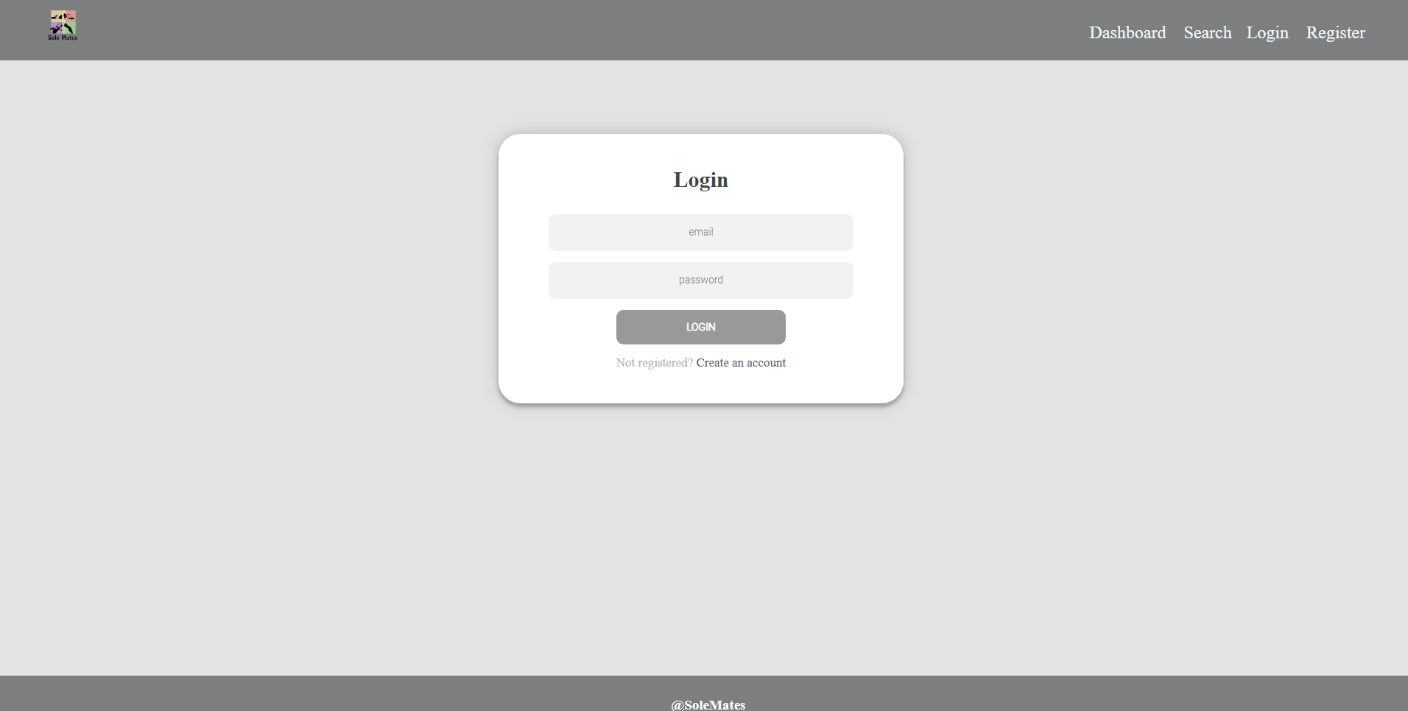

Send the following **request** to perform login:

Method: POST

URL: /users/login

Required **headers** are described in the documentation. The service expects a body with the following shape:

{

email,

password

}

Upon success, the **REST service** will return the newly created object with an automatically generated **_id** and a property **accessToken**, which contains the **session token** for the user **–** you need to store this information using **sessionStorage** or **localStorage,** in order to be able to perform authenticated requests.

If the login was successful, **redirect** the user to the **Dashboard** page. If there is an error, or the **validations** don’t pass, display an appropriate error message, using a system dialog (window.alert).

### Register User (10 pts)

By given **email,** **password** app should register a new user in the system. All fields are required – if any of them is empty, display an error.

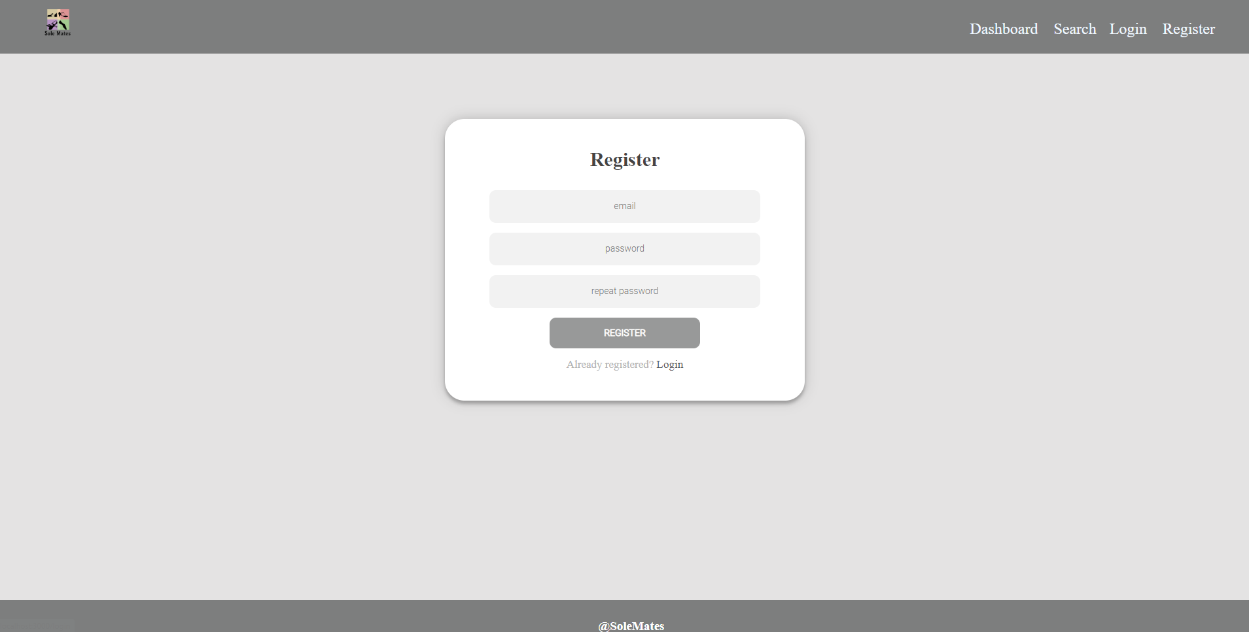

Send the following **request** to perform registration:

Method: POST

URL: /users/register

Required **headers** are described in the documentation. The service expects a body with the following shape:

{

email,

password

}

Upon success, the **REST service** will return the newly created object with an automatically generated **_id** and a property **accessToken**, which contains the **session token** for the user **–** you need to store this information using **sessionStorage** or **localStorage,** in order to be able to perform authenticated requests.

If the registration was successful, **redirect** the user to the **Dashboard** page. If there is an error, or the **validations** don’t pass, display an appropriate error message, using a system dialog (window.alert).

### Logout (5 pts)

The logout action is available to **logged-in users**. Send the following **request** to perform logout:

Method: GET

URL: /users/logout

Required **headers** are described in the documentation. Upon success, the **REST service** will return an **empty response**. Clear any session information you’ve stored in browser storage.

If the logout was successful, **redirect** the user to the **Dashboard** page.

### Dashboard (15 pts)

This page displays a list of all shoes in the system. Clicking on the details button in the shoe card leads to the details page for the selected shoe. This page should be visible to guests and logged-in users.

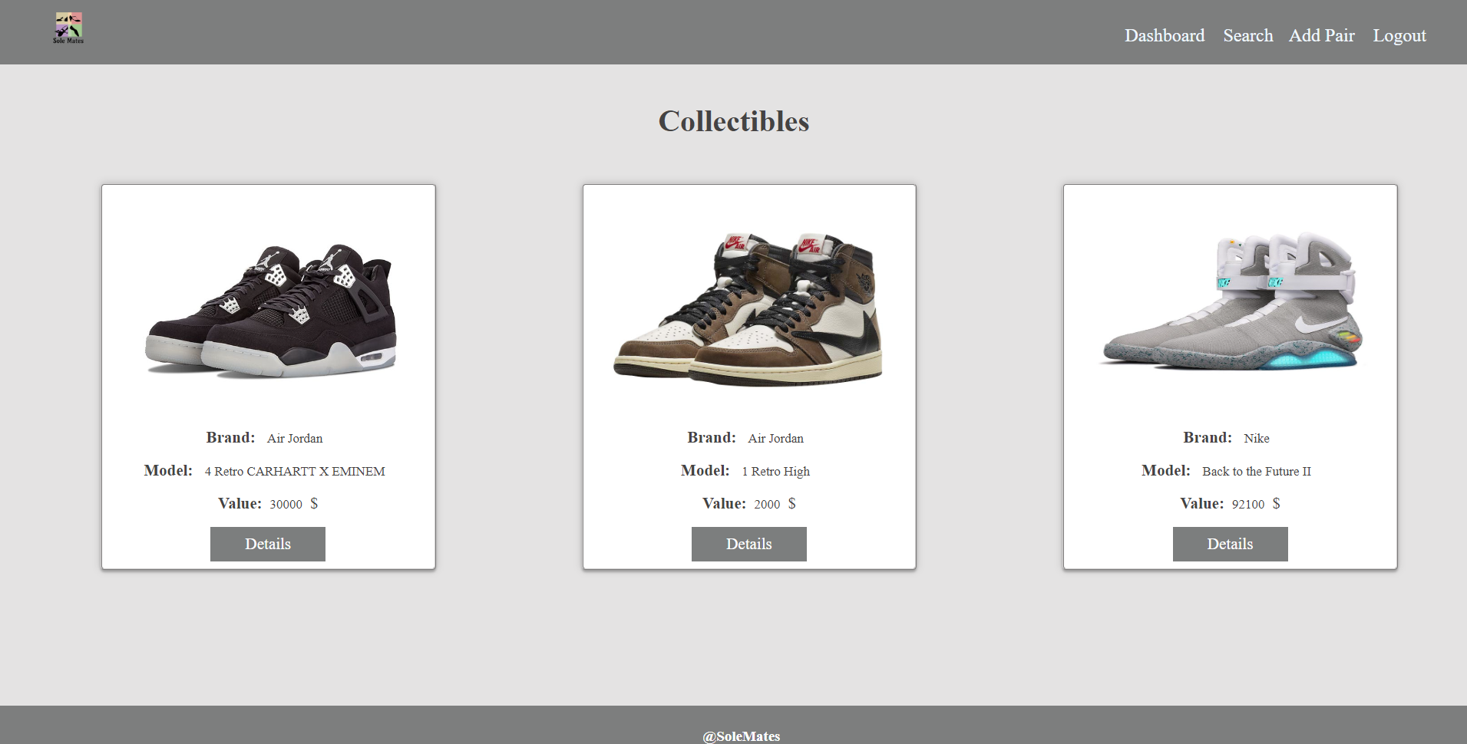

If there are **no shoes**, the following view should be displayed:

Картина, която съдържа текст

Описанието е генерирано автоматично

Send the following **request** to read the list of ads:

Method: GET

URL: /data/shoes?sortBy=_createdOn%20desc

Required **headers** are described in the documentation. The service will return an array of shoes.

### Adding New Item(15 pts)

The Create page is available to **logged-in users**. It contains a form for adding a new shoe. Check if all the fields are filled before you send the request.

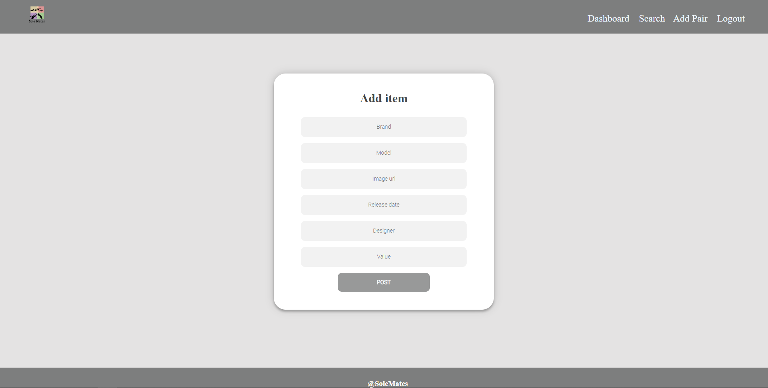

To create a shoe, send the following **request**:

Method: POST

URL: /data/shoes

Required **headers** are described in the documentation. The service expects a body with the following shape:

{

brand,

model,

imageUrl,

release,

designer,

value

}

Required **headers** are described in the documentation. The service will return the newly created record. Upon success, **redirect** the user to the **Dashboard** page.

### Item Details (10 pts)

All users should be able to **view details** aboutshoes. Clicking the **Details** link in of a **shoe card** should **display** the **Details** page. If the currently **logged-in user** is the **creator**, the **Edit** and **Delete** buttonsshould be displayed, otherwise they should not be available. The view for the **creators** should look like:

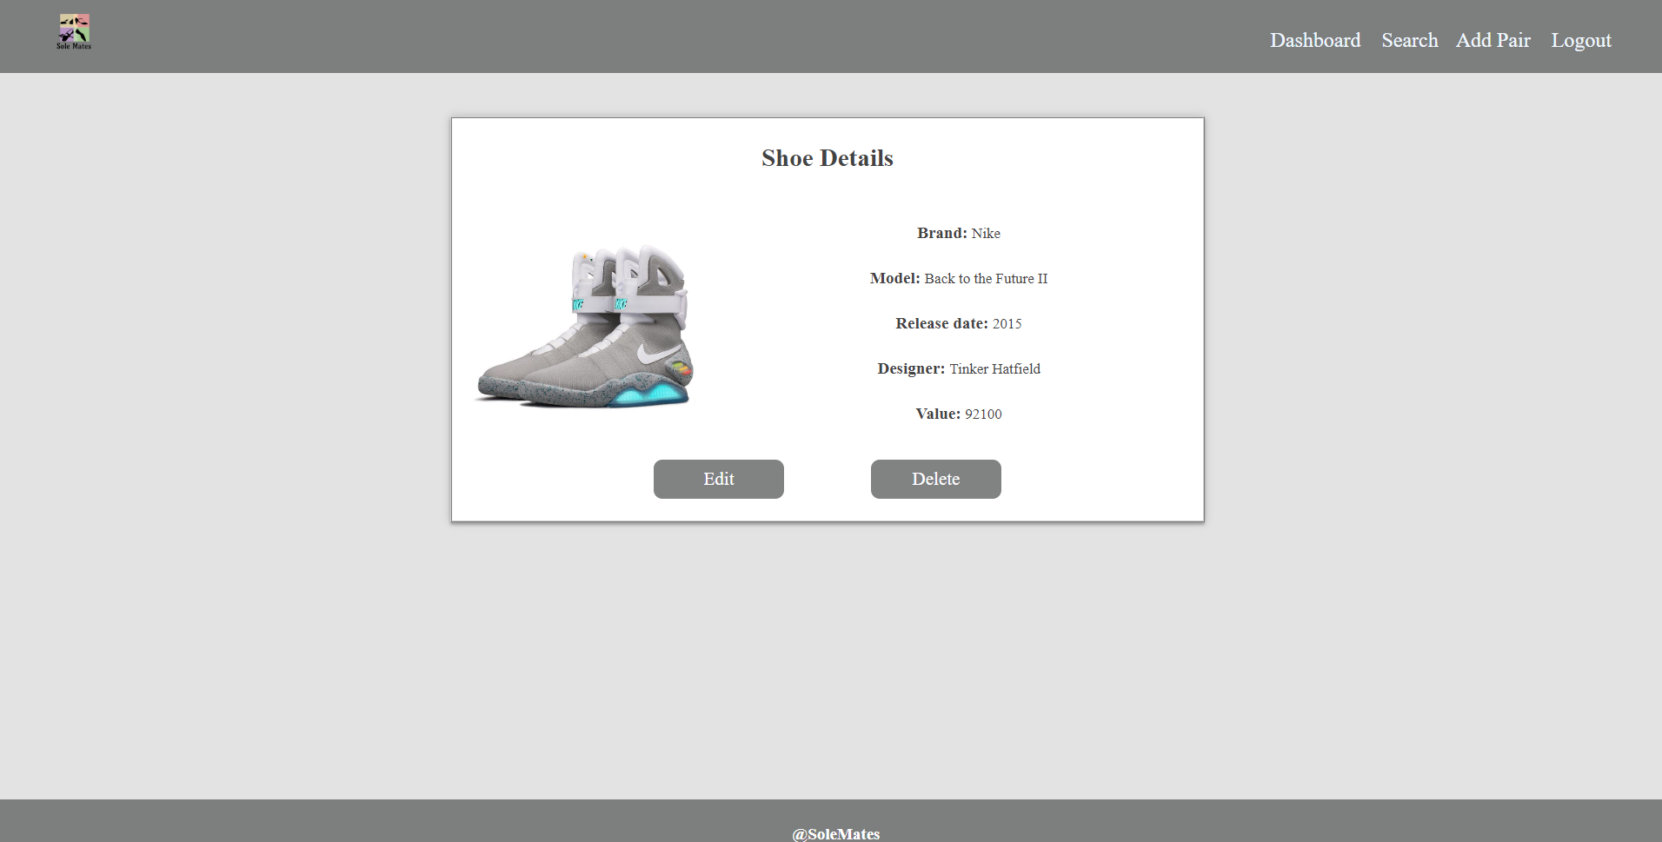

The view for **guests** should look like:

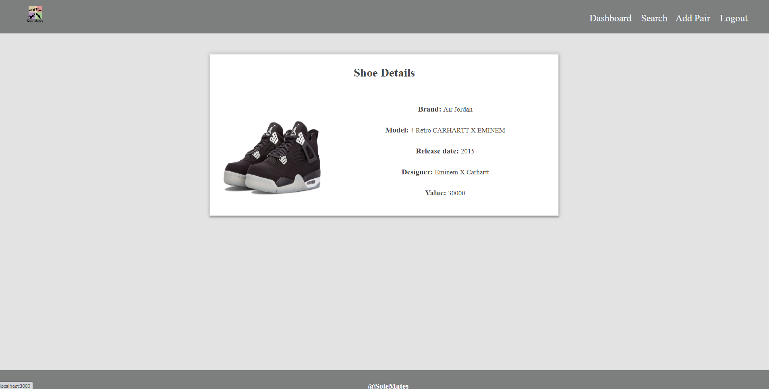

Send the following **request** to read a single shoe:

Method: GET

URL: /data/shoes/:id

Where ***:id*** is the **id** of the desired card. Required **headers** are described in the documentation. The service will return a single object.

### Edit Item Screen (15 pts)

The Edit page is available to logged-in users and it allows authors to **edit** their **own** item. Clicking the **Edit** link of a particular shoe on the **Details** page should display the **Edit** page, with all fields filled with the data for the shoe. It contains a form with input fields for all relevant properties. Check if all the fields are filled before you send the request.

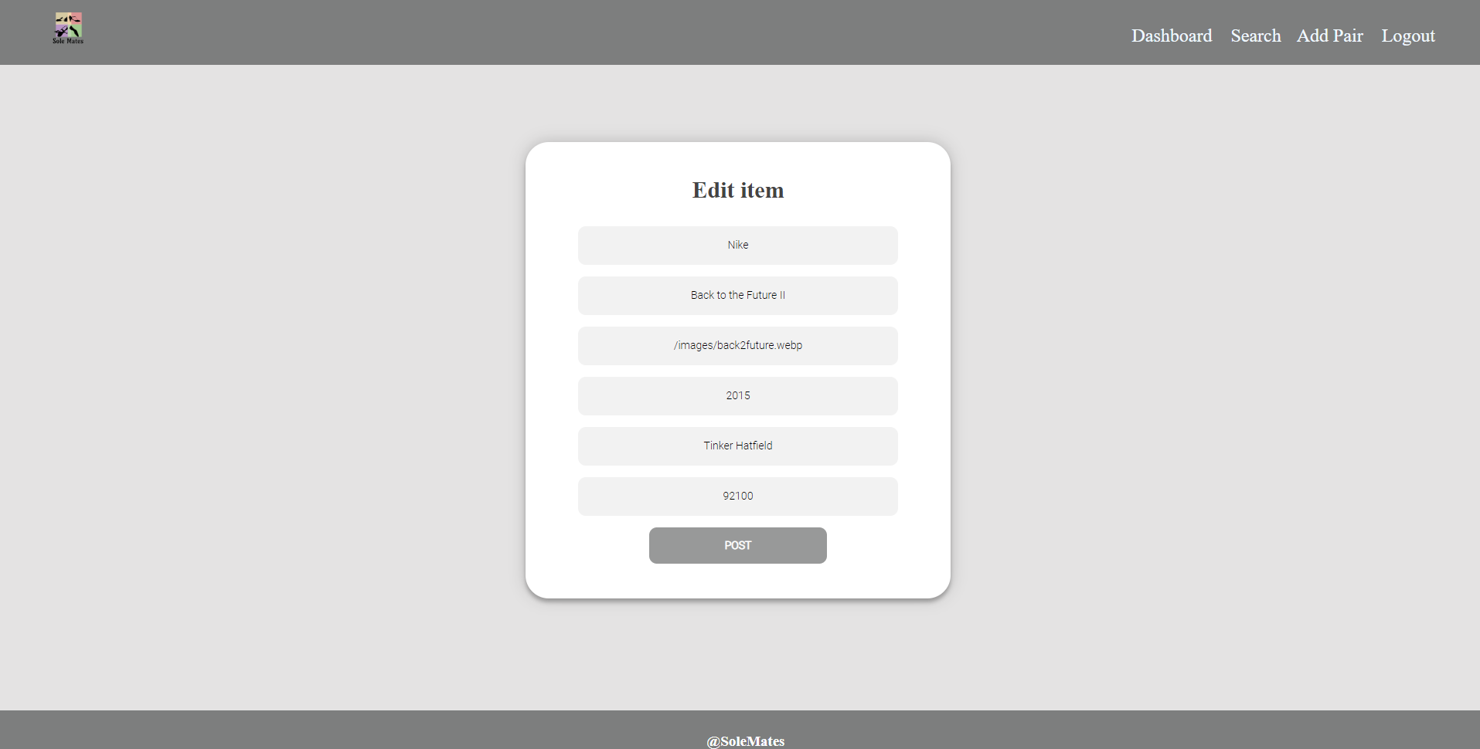

To edit a shoe, send the following **request**:

Method: PUT

URL: /data/shoes/*:id*

Where ***:id*** is the **id** of the desired card.

The service expects a **body** with the following shape:

{

brand,

model,

imageUrl,

release,

designer,

value

}

Required **headers** are described in the documentation. The service will return the modified record. Note that **PUT** requests **do not** merge properties and will instead **replace** the entire record. Upon success, **redirect** the user to the **Details** page for the current shoe.

### Delete Item (10 pts)

The delete action is available to **logged-in users**, for items they have created. When the author clicks on the Delete action on any of their items, **a confirmation dialog should be displayed**, and upon confirming this dialog, the item should be **deleted** from the system.

To delete an shoe, send the following **request**:

Method: DELETE

URL: /data/shoes/*:id*

Where ***:id*** is the **id** of the desired item. Required **headers** are described in the documentation. The service will return an object, containing the deletion time. Upon success, **redirect** the user to the **Dashboard** page.

### (BONUS) Search Page (10 pts)

The **Search page** allows both users and guests to filter shoes by their brand. It contains an input field and, upon submitting a query, a list of all matching shoes. Check if the **field** is **filled** before you send the request.

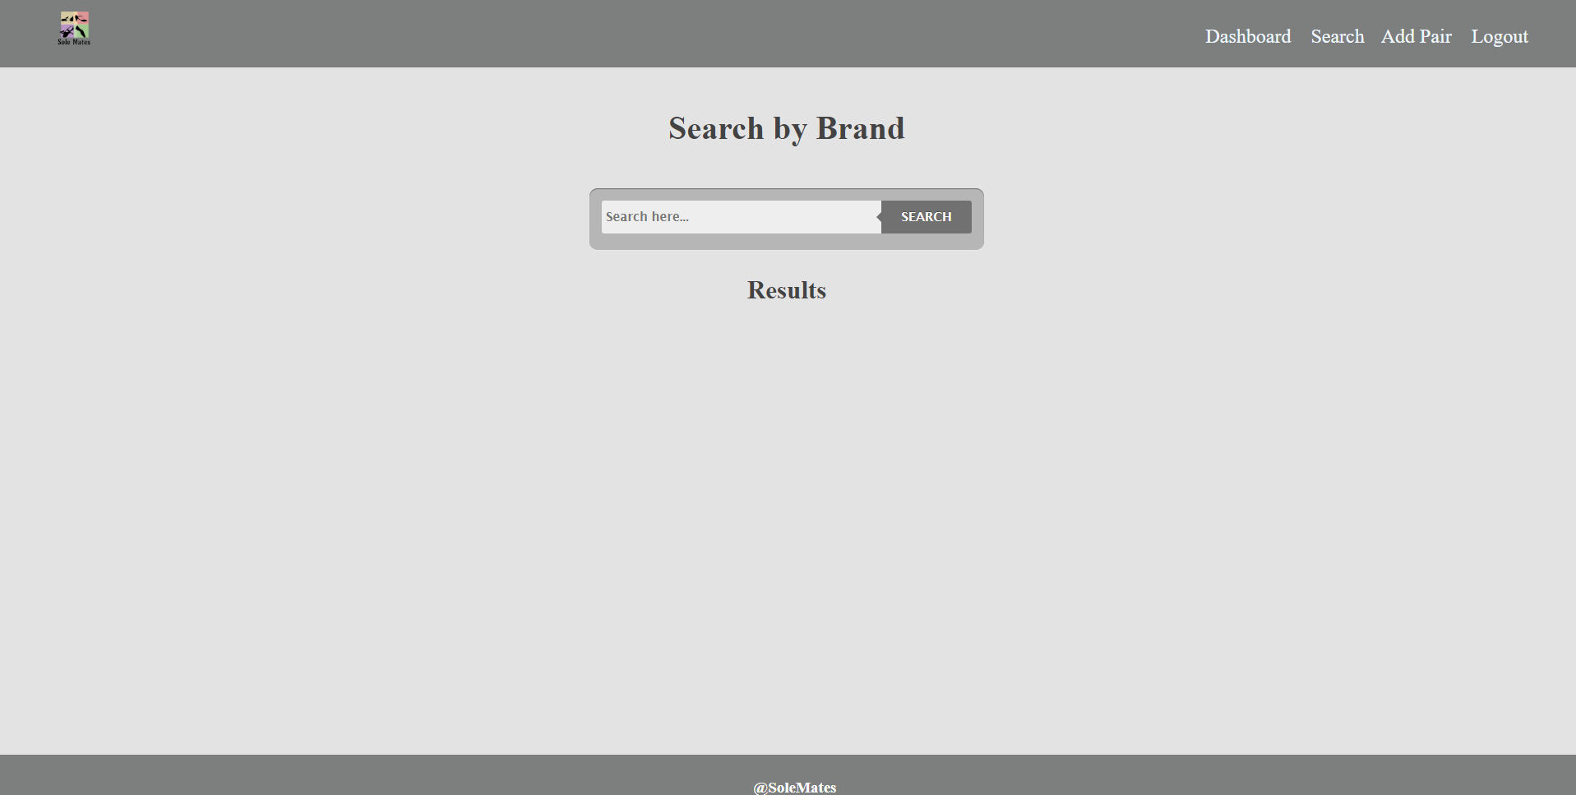

Details button should be visible if the user is logged in.

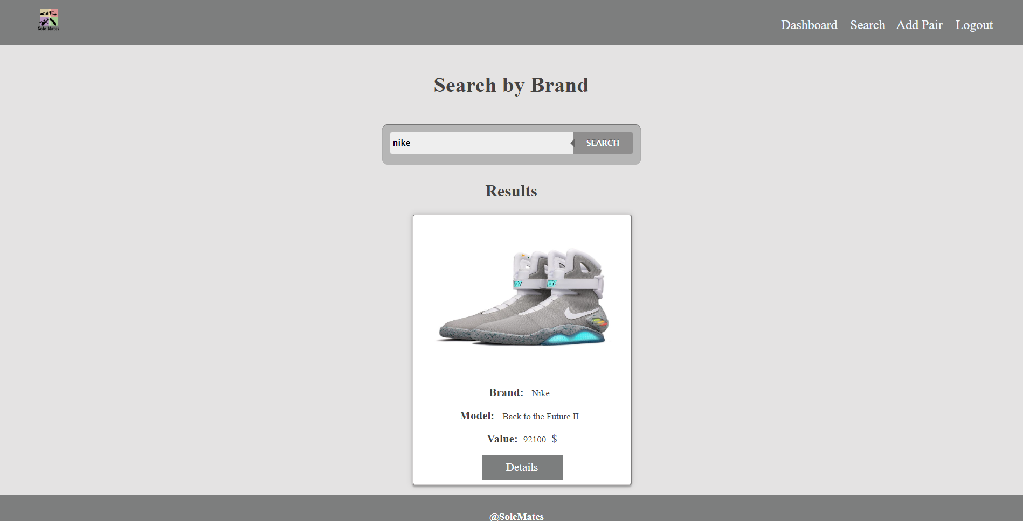

Details button should be invisible if the user is logged out.

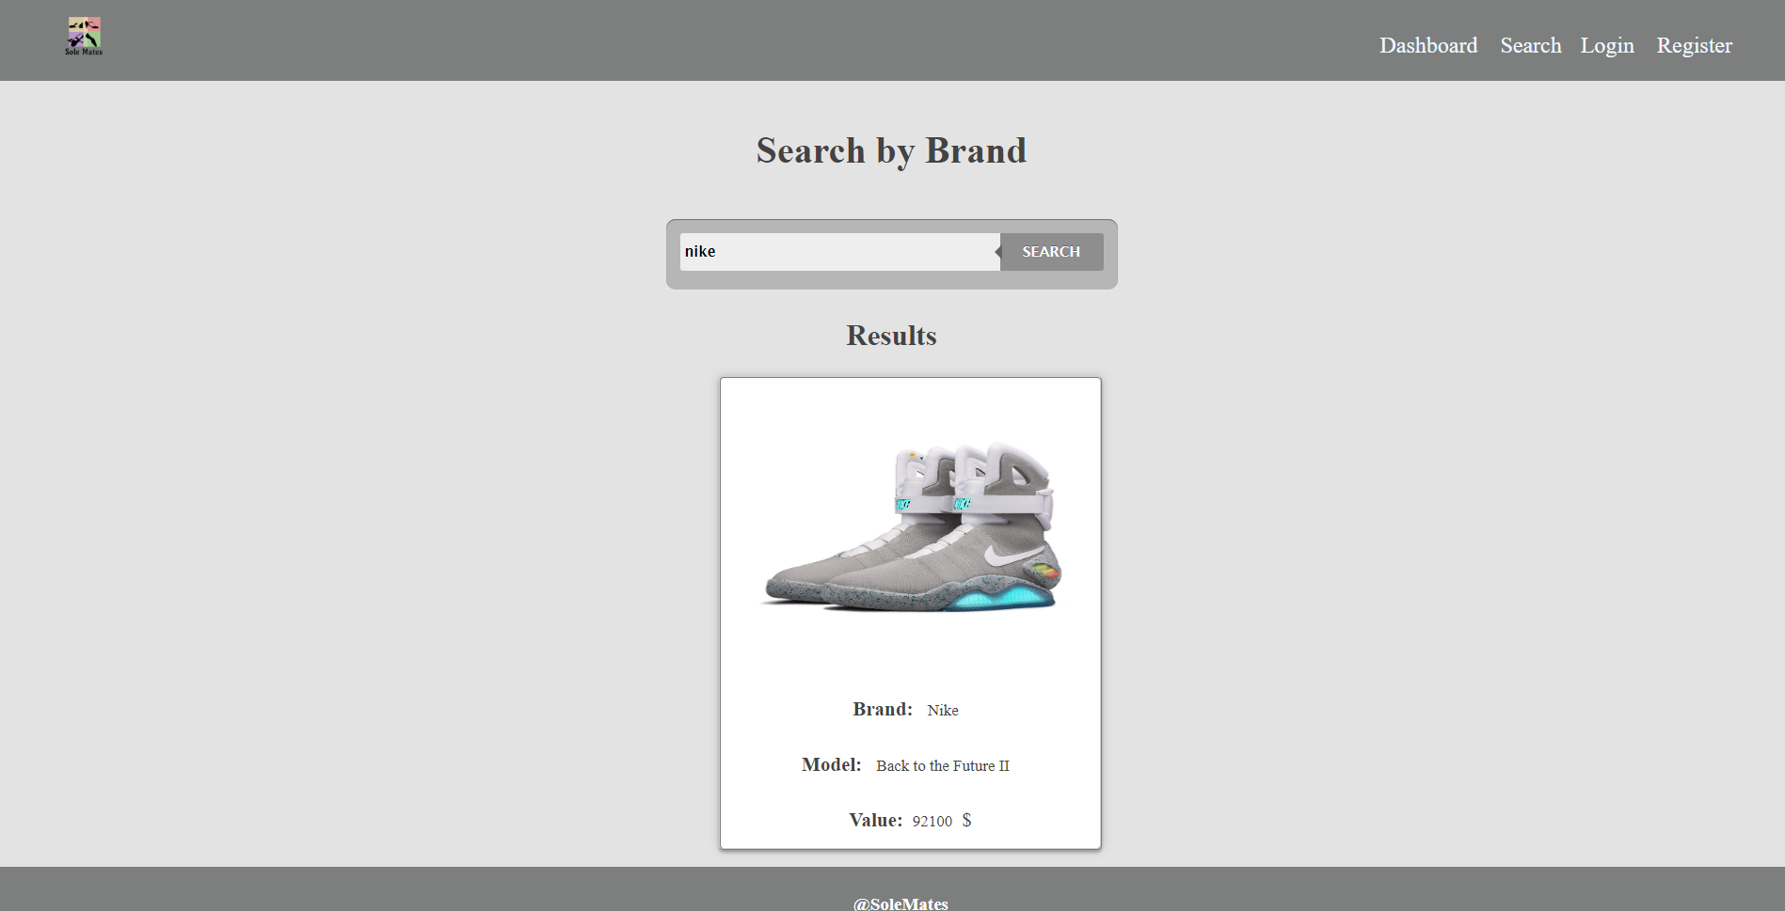

If there are noresults, the following view should be displayed:

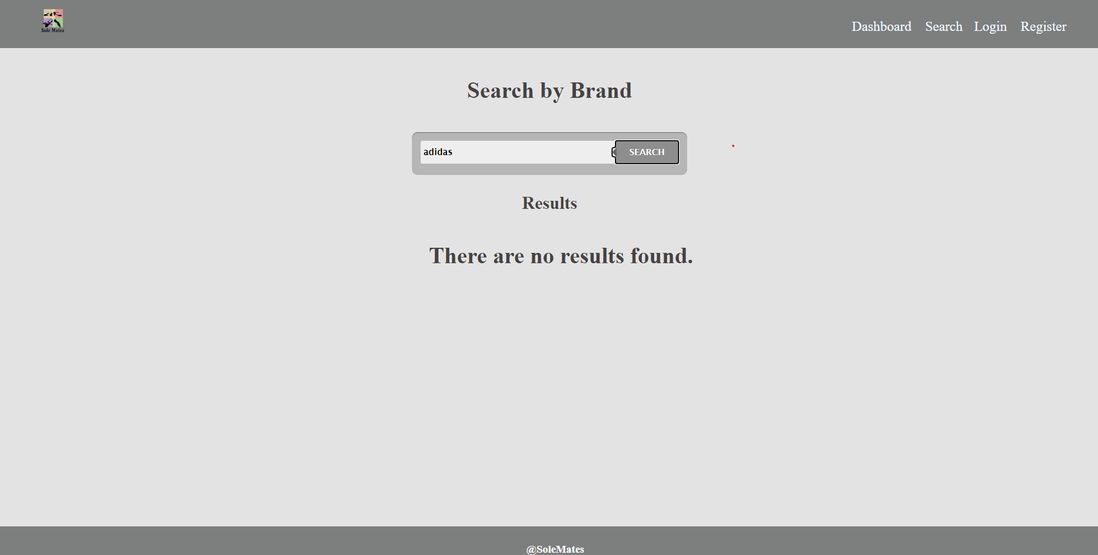

Send the following request to read a filtered list of shoes by their brand:

Method: GET

URL: /data/shoes?where=brand%20LIKE%20%22${query}%22

## Subtmitting Your Solution

Place in a **ZIP** file your project folder. Exclude the node_modules folder. Do not include the solution in another folder into the zip. Upload the archive to Judge.

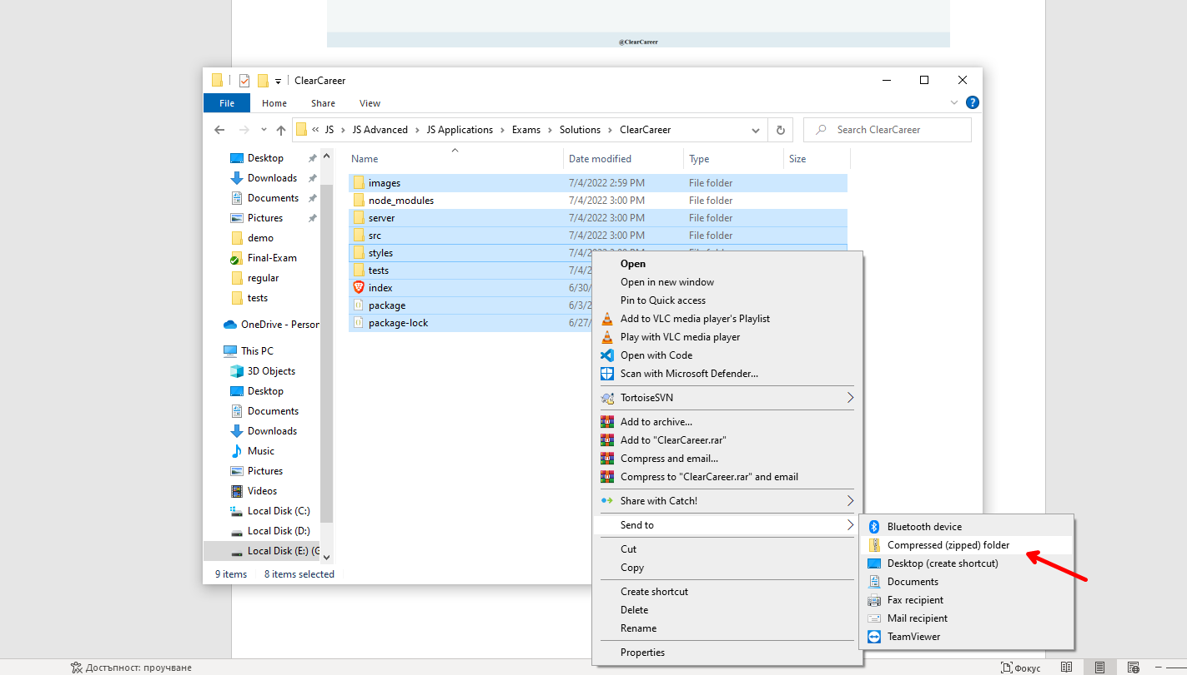

Картина, която съдържа текст, екранна снимка, закрито

Описанието е генерирано автоматично

**It will take several minutes for Judge to process your solution!**

## Appendix A: Using the Local REST Service

### Starting the Service

The REST service will be in a folder named “server” inside the provided resources archive. It has no dependencies and can be started by opening a terminal in its directory and executing:

node server.js

If everything initialized correctly, you should see a message about the **host address and port** on which the service will respond to requests.

### Sending Requests

To send a request, use the **hostname** and **port**, shown in the initialization log and **resource address** and **method** as described in the **application requirements**. If data needs to be included in the request, it must be **JSON-encoded**, and the appropriate **Content-Type** **header** must be added. Similarly, if the service is to return data, it will be JSON-encoded. Note that **some requests do not return a body** and attempting to parse them will throw an exception.

Read requests, as well as login and register requests do not require authentication. All other requests must be authenticated.

### Required Headers

To send data to the server, include a **Content-Type** header and encode the body as a JSON-string:

Content-Type: application/json

*{JSON-encoded request body as described in the application requirements}*

To perform an authenticated request, include an **X-Authorization** header, set to the value of the **session token**, returned by an earlier login or register request:

X-Authorization: *{session token}*

### Server Response

Data response:

HTTP/1.1 200 OK

Access-Contrl-Allow-Origin: *

Content-Type: application/json

*{JSON-encoded response data}*

Empty response:

HTTP/1.1 204 No Content

Access-Contrl-Allow-Origin: *

Error response:

HTTP/1.1 400 Request Error

Access-Contrl-Allow-Origin: *

Content-Type: application/json

*{JSON-encoded error message}*

### More Information

You can find more details on the [GitHub repository of the service](https://github.com/softuni-practice-server/softuni-practice-server/blob/master/README.md).

## Appendix B: Running the Test Suite

### Project Setup

The tests require a web server to deliver the content of the application. There is a development web server included in the project scaffold, but you may use whatever server you are familiar with. Note that specialized tools like **BrowserSync** may interfere with the tests. To initialize the project with its dependencies, open a terminal in the folder, containing the file package.json and execute the following:

npm install

Note that if you changed the section devDependencies of the project, the tests may not initialize properly.

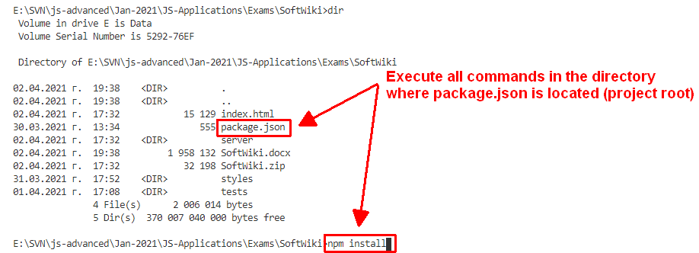

### Executing the Tests

Before running the test suite, make sure a web server is operational, and the application can be found at the root of its network address. To start the included dev-server, open a terminal in the folder containing package.json and execute:

npm run start

This is a one-time operation unless you terminate the server at any point. It can be restarted with the same command as above.

To execute the tests, open a new terminal (do not close the terminal, running the web server instance) in the folder containing package.json and execute:

npm run test

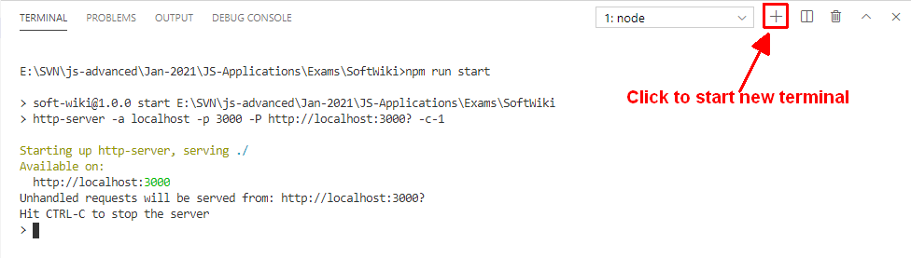

Test results will be displayed in the terminal, along with detailed information about encountered problems. You can perform this operation as many times as it is necessary by re-running the above command.

### Debugging Your Solution

If a test fails, you can view detailed information about the requirements that were not met by your application. Open the file e2e.test.js in the folder tests and navigate to the desired section as described below.

**This first step will not be necessary if you are using the included web server.** Make sure the application host is set correctly:

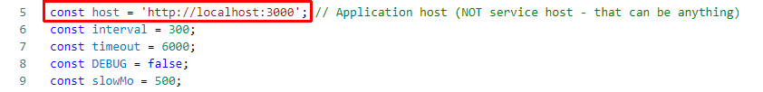

The value for host must be the address where your application is being served. Make sure that entering this address in a regular internet browser shows your application.

To make just a single test run, instead of the full suite (useful when debugging a single failing test), find the test and append .only after the it reference:



On slower machines, some of the tests may require more time to complete. You can instruct the tests to run more slowly by slightly increasing the values for interval and timeout:

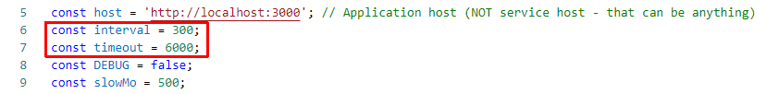

Note that interval values greater than 500 and timeout values greater than 10000 are not recommended.

If this doesn’t make the test pass, set the value of DEBUG to true and run the tests again – this will launch a browser instance and allow you to see what is being tested, what the test sees and where it fails (or hangs):

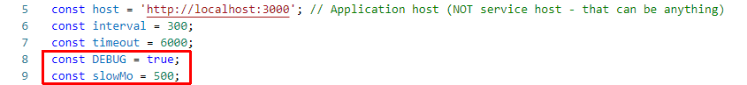

If the actions are happening too fast, you can increase the value of slowMo. If the browser hangs, you can just close it and abort any remaining tests by focusing the terminal window and pressing [Ctrl+C] followed by the letter "y" and [Enter].

The final thing to look for is the exact row where the test fails:

